LOVELY PROFESSIONAL UNIVERSITY
BACHELOR OF TECHNOLOGY
in
COMPUTER SCIENCE AND ENGINEERING



Student Name  Shaik Arif
Student ID  11812327
Email Address  skaref3344@gmail.com
Github link-

Consider a scheduler which schedules the job by considering the arrival time of the processes where arrival time if given as 0 is discarded or displayed as error. The scheduler implements the shortest job first scheduling policy, but checks the queue of the processes after every process terminates and time taken for checking and arranging the process according to the shortest job is 2-time unit. Compute the waiting time, average waiting time and turnaround time of the processes. Also compute the total time taken by the processor to compute all the jobs.
The inputs for the number of requirements, arrival time and burst time should be provided by the user. Consider the following units for reference.
Process Arrival time Burst Time
1 0 6
2 3 2
3 5 1
4 9 7
5 10 5
6 12 3
7 14 4
8 16 5
9 17 7
10 19 2
Develop a scheduler which submits the processes to the processor in the defined scenario, and compute the scheduler performance by providing the waiting time for process, and average waiting time and turnaround time.

Description:
- Shortest Job Frist is a scheduling policy that selects for executing the waiting process with the smallest execution time. Shortest Job First is a non-preemptive algorithm i.e. the scheduling in which a running process cannot be interrupted by any other process is called non-preemptive scheduling, and one of the most common scheduling algorithm in batch system. SJF is advantageous because of its simplicity and because it minimizes the average amount of time, each process has to wait until its execution is completed.

Algorithm:
- Sort all the process according to the arrival time.
- Then select that process which has minimum arrival time and minimum Burst time.
- After completion of process make a pool of process which after till the completion of previous process and select that process among the pool which is having minimum Burst time.
- Then calculate the waiting time for all the process.
- Then calculate the average time for the whole program.

Definitions of the Terms:
- Burst time: it is the total time taken by the process for its execution on the CPU.
- Arrival time: it is the time when a process enters into the ready state and is ready for its execution.
- Waiting time: it is the total time spent by the process in the ready state waiting for CPU.
Waiting time = Turnaround time - Burst time
- Turnaround time: it is the total amount of time spent by the process from coming in the ready state for the first time to its completion.
Turnaround time = Burst time + Waiting time
- Response time: it is the time spent when the process is in the ready state and gets the CPU for the first time.
Response time = Time at which the process gets the CPU for the first time - Arrival time
- Exit time: it is the time when a process completes its execution and exit from the system.
Description (purpose of use):
- Completion Time: Time at which process completes its execution.
- Turn Around Time: Time Difference between completion time and arrival time.
Turn Around Time = Completion Time  Arrival Time
- Waiting Time(W.T): Time Difference between turnaround time and burst time.
Waiting Time = Turn Around Time  Burst Time

Source Code:

#include<stdio.h>
#include<stdlib.h>

struct process
{
int process_no;
int p_arrival;
int process_burst;

};
struct result
{
int final_pno;
int waiting_time;
int turnaround_time;
};
int main()
{
printf("\n\n\t\t\t\t\t*PROBLEM STATEMENT*\n");
printf("\n\t\t3. Consider a scheduler which schedules the job by considering the arrival time of the \n\tprocesses where arrival time if given as 0 is discarded or displayed as error. The scheduler \n\timplements the shortest job first scheduling policy, but checks the queue of the processes after \n\tthe every process terminates and time taken for checking and arranging the process according \n\tto the shortest job is 2 time unit. Compute the waiting time, turnaround time and average waiting \n\ttime and turnaround time of the processes. Also compute the total time taken by the processor \n\tto compute all the jobs.");
printf("\n\n\n");
system ("PAUSE");

system("cls");
struct process prc_obj[30];
struct result res[30];
int i,n,j,choice1,choice2,pos,min,pro_exec,time=0,end,k,flag,ideal_time;
X: Y: printf("Enter the no. of processes-");
scanf("%d",&n);

for(i=1;i<=n;i++)
{
printf("\n\t For Process P%d\n",i);
prc_obj[i].process_no=i;
printf("\t\tEnter Arrival Time:");
scanf("%d",&prc_obj[i].p_arrival);
printf("\t\tEnter Burst Time:");
scanf("%d",&prc_obj[i].process_burst);

}
printf("\n\tPress 1 to proceed to result or press 2 to re-enter the details ");
scanf("%d",&choice1);
if(choice1==2){

system("cls");
goto X;
}

time!=0;
for(i=1;i<=n;i++)
{
if(prc_obj[i].p_arrival==0)
{
printf("\t\tProcess- %d Discared! Incorrect arrival time provided.",i);
for(j=i;j<n;j++)
{
prc_obj[j]=prc_obj[j+1];
}
time=prc_obj[i].p_arrival;
n--;
i--;
}
if(prc_obj[i].p_arrival<time )
{
time=prc_obj[i].p_arrival;
}
}
end = n;
min=0;
k=1;
while(n>0)
{
pro_exec=prc_obj[1].process_burst;
ideal_time=time+1;
flag=0;
for(j=1;j<=n;j++)
{

if(pro_exec>=prc_obj[j].process_burst && prc_obj[j].p_arrival<=time)
{
pro_exec = prc_obj[j].process_burst;
pos=j;
flag=1;
}
if(ideal_time>time && ideal_time>prc_obj[j].p_arrival && prc_obj[j].p_arrival!=time)
{
ideal_time=prc_obj[j].p_arrival;
}
}
if(flag==1)
{
if(pos==1)
{
res[k].waiting_time=time-prc_obj[pos].p_arrival;
time = time + pro_exec;
res[k].turnaround_time=time-prc_obj[pos].p_arrival;
}
else
{
res[k].waiting_time=time-prc_obj[pos].p_arrival+2;
time = time + pro_exec;
res[k].turnaround_time=time-prc_obj[pos].p_arrival+2;
}
res[k].final_pno=prc_obj[pos].process_no;
for(i=pos;i<n;i++)
{
prc_obj[i]=prc_obj[i+1];
}
n--;
k++;

}
else //CPU ideal time
{
time = ideal_time;
}

}
system("cls");
printf("Order of execution of processes are:\n");
for(i=1;i<=end;i++)
{
printf(" P%d-->",res[i].final_pno);
}
printf("FINISH");
printf("\n\n\n\t *******************************************************");
printf("\n\t * PROCESS : WAITING TIME : TURNAROUND TIME *");
for(i=1;i<=end;i++)
{
printf("\n\t * P%d : %d : %d *",res[i].final_pno,res[i].waiting_time,res[i].turnaround_time);

}
printf("\n\t *******************************************************");

float sum2=0;
float sum1=0;
for(i=1;i<=end;i++)
{
sum2=sum2+res[i].turnaround_time;}
float average_tat=sum2/end;
printf("\n\tAverage Turn around time is: %f",average_tat);
for(i=1;i<=end;i++)
{
sum1=sum1+res[i].waiting_time;}
float average_wt=sum1/end;
printf("\n\tAverage Waiting time is: %f",average_wt);
printf("\n\tPress 1 to calculate again or press 2 to exit: ");
scanf("%d",&choice1);
if(choice1==1){

system("cls");
goto Y;
}

return 0;
}

Output:
Output of the given question:
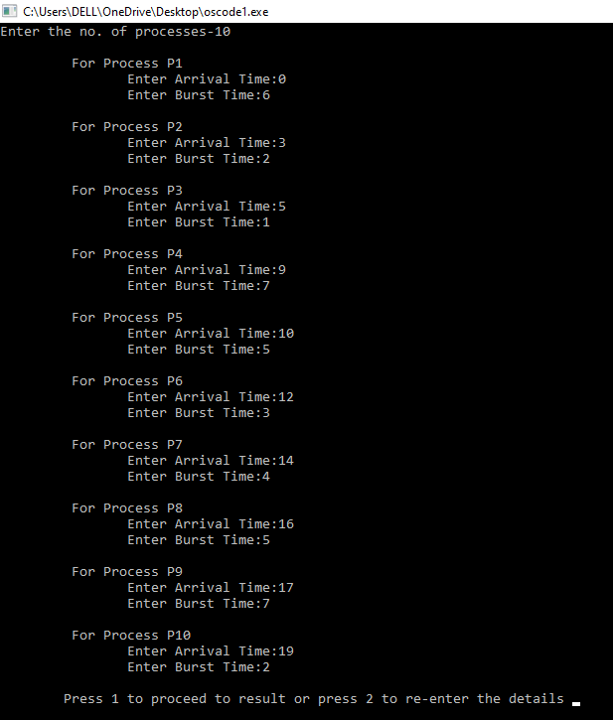
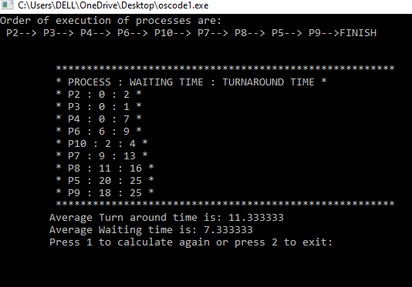

Test Cases:
Test case 1: 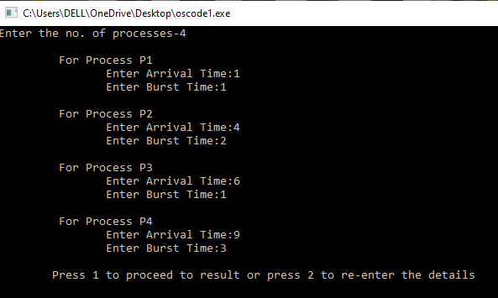
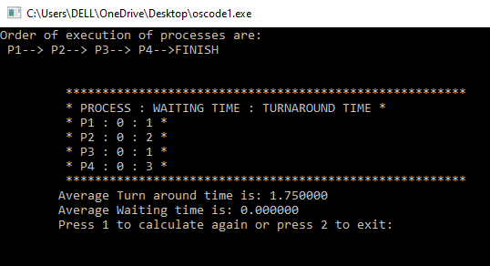

Test case 2:
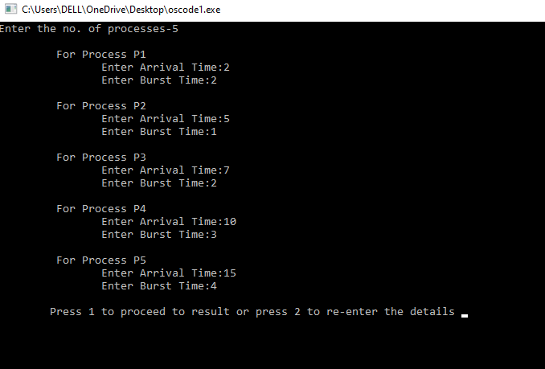
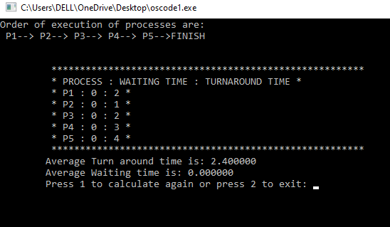

Boundary Conditions:
- The number of processes should be positive.
- Arrival time should be positive.
- Burst time should be positive.

GitHub Link:

